Neighbors Helping Neighbors Since 1888
scio FIRE district
P.O. Box 1 Scio, OR 97374 ∗ 503-394-3000

Hot Topics 12/8/25

At drill last Monday, we celebrated Shane Barker receiving their FF Type 2 certification
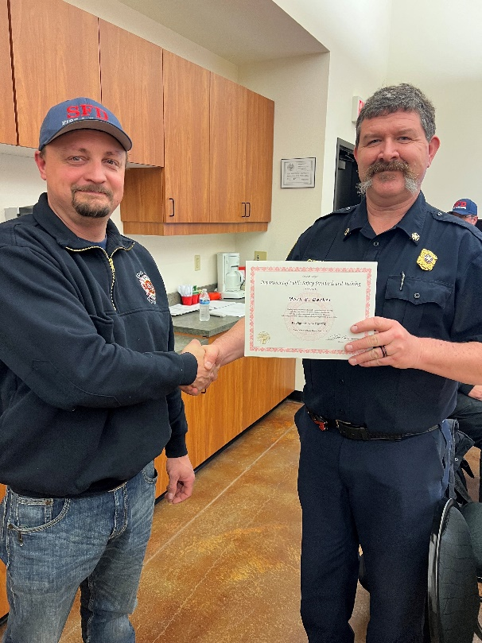
There is a new lock box hanging on the wall that will have Narcan, Epi, Albuterol, and a few other expensive things in it. Our inventory numbers suggest that some EMS supplies have come up missing and this is an attempt to curb that. Chief and Jaime have keys. If you need to restock one of the first-out rigs and neither the chief nor Jaime are available, take the supplies you need from one of the vehicles that doesn’t roll very often (B94 for example) and leave the chief a note.
Chief handed out points checks at Monday’s drill. Checks that weren’t picked up on Monday are being held in the chief’s office. See the chief to get them.
We will be conducting ESO NERIS training on January 5th and January 12th. NERIS is the new reporting system that everyone needs to know.
The volunteers collected about $4,500 during the Feed the Boot on Saturday morning!

Thanks to those who came out to Station 92 for Santa Night. We had somewhere around 35 kids show up.
We will build food boxes next Friday the 12th starting at 6pm. We will hand out (and deliver some) boxes on Sunday the 14th starting at 11am.
Chief talked about the Hess Rd. MVC we were dispatched to on Sunday.




