Neighbors Helping Neighbors Since 1888
scio FIRE district
P.O. Box 1 Scio, OR 97374 ∗ 503-394-3000

Hot Topics 12/1/25

At drill last Monday, we celebrated Mandy Boyer and Jaime Montgomery for receiving their FF Type 2 certification
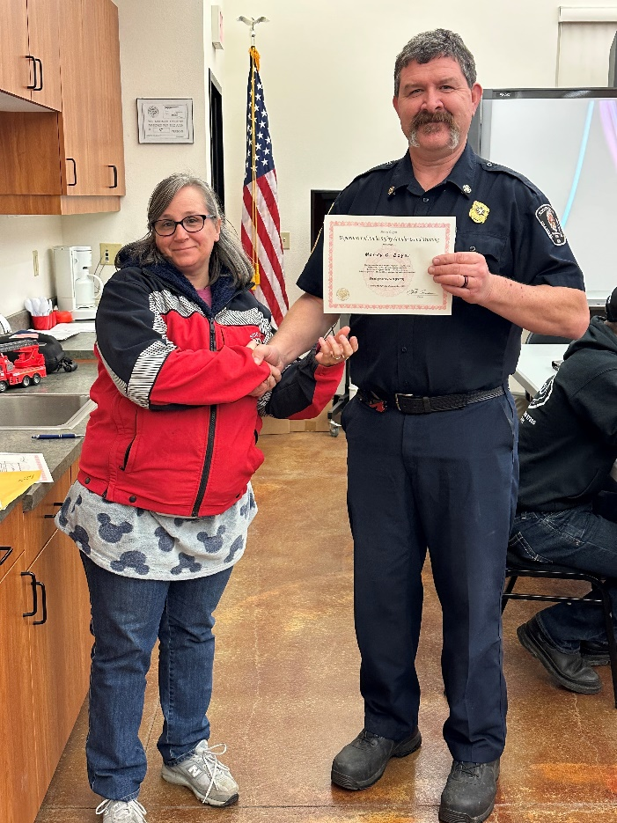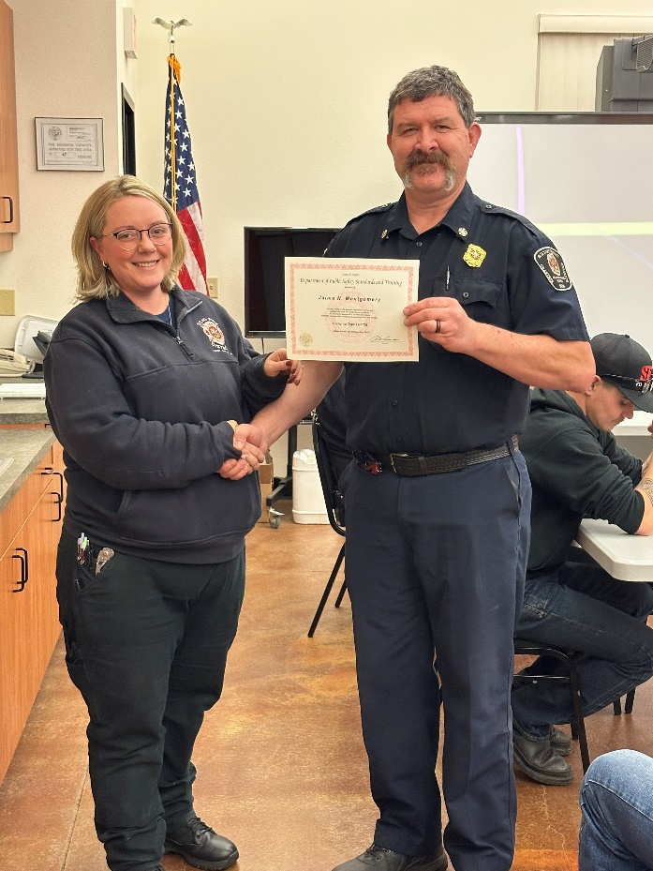
Fit testing is ongoing for the 7 new members who will start academy next month. Several got tested at Monday’s drill. We will try to get the rest at next Monday’s drill.
Next Saturday is Feed the Boot and Santa Night. For Feed the Boot, we will meet at Station 91 at 0830 for breakfast. Plan on staying out until noon. It’s supposed to rain so dress appropriately. For Santa Night, please arrive at Station 92 at 1700. It’ll take an hour or so to get everything set up. Then dinner at 1800. Santa arrives at 1900.
A quick note on inventory checks – please make sure they are thorough (don’t pencil whip). Make sure that you are seeing the piece of equipment that you are checking off (don’t just assume it’s there). If you don’t know what a tool is called, ask someone. If you find discrepancies, please let me know.
At drill a couple weeks ago, we celebrated Chelsea Braatz, whose grant has ended. We thank her for her work and wish her luck in the future.
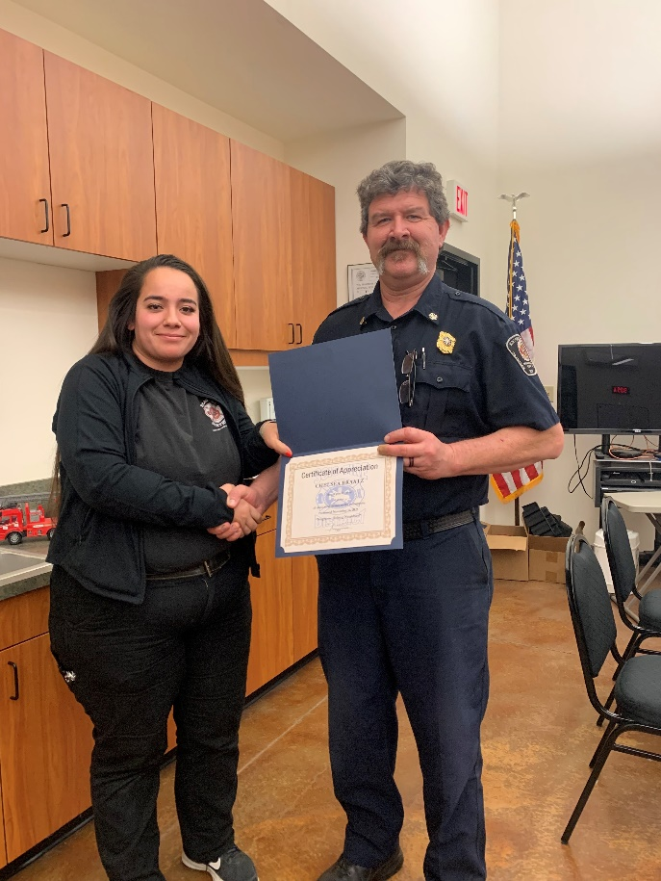
As most of you know, we are going through an evaluation from the Insurance Services Office. The ISO rates fire departments based on several factors like access to hydrants, type of equipment carried on the rigs, and number of personnel that show up at fires. One of the tasks that we are required to do is conduct an evolution called a Fire Site Setup and record it. We did this at a recent drill, and it came out pretty good. Here is a link to the drill. https://youtu.be/UbHvbXfHg-Y
Our reporting system is changing. Currently we log into ESO to do our Incident Reports and our Medical Reports. That part isn’t changing. What is changing is that ESO currently sends our report information to NFIRS (National Fire Incident Reporting System). The Feds are mandating a change to NERIS (National Emergency Response Information System). Every fire department in the country will be required to switch to NERIS by January 1st. We will still use ESO to create our reports, but the screens will be different, drop downs different, everything will be different. Rebecca and I have been monitoring the new program and personally, it doesn’t look like it’s going to be the end of the world. But it will take you some time and practice before you are comfortable with it. There are several webinars that you can participate in. At this time, they aren’t recorded so you will have to watch them live. You can register for a webinar by going here: Webinar Registration - Zoom. We will conduct training on the new reporting system after the first of the year and I’m sure it will be well attended.

***

